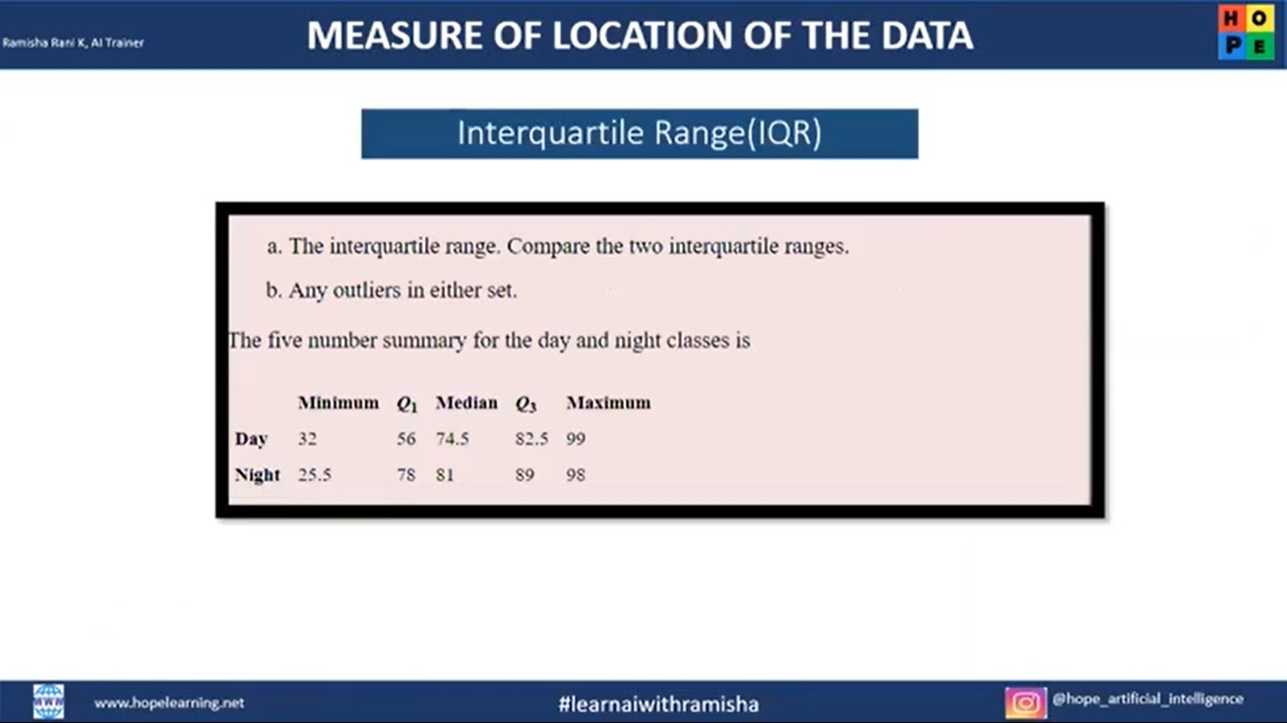

a.

Interquartile range:

IQR_day = Q3-Q1 = 82.5-56 = 26.5

Lower whisker = 56 - (1.5*26.5) = 56 - 39.75 = 16.25

Upper whisker = 82.5 + (1.5*26.5) = 82.5 + 39.75 = 122.75

IQR_night = Q3-Q1 = 89-78 = 11

Lower whisker = 78 - (1.5*11) = 78 - 16.5 = 61.5

Upper whisker = 89 + (1.5*11) = 89 + 16.5 = 105.5

b.

There are no outliers in the day class, because min(32) and max(82.5) values lie between the lower whisker and upper whisker.

But in the night class, there is the enter level outlier because min(25.5) value is less than the lower whisker and then max(98) value is not greater than the upper whisker so it is not outlier.